SEM Overview
Incorporating the geometric flexibility of FEM and rapid convergence of spectral methods, the SEM shows advantages in terms of accuracy and flexibility to treat complicated and heterogeneous domains ((Komatitsch et al. 2004; Lee et al. 2008; Paolucci et al. 2014; Wu et al. 2022). This subsection briefly describes the SEM to solve wave propagation, including the weak form of governing equations, the domain discretization, and the integral algorithm. The readers can refer to Faccioli et al. (1997), Komatitsch & Vilotte (1998) for formula derivation of SEM.
Considering an elastic inhomogeneous region Ω ⸦ R^{nd} bounded by physical boundaries with prescribed traction Γ_{T} and displacement Γ_{g} respectively, the boundary value problem can be formulated as
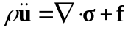 (1)
where n_{d} is the space dimension being two or three, ρ is the density, u and σ are the displacement and stress at a point x with x∈Ω. The dot over a symbol represents the time differentiation. f is the generalized force and only the point source derived from the seismic moment is considered herein
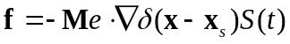 (2)
where Me is the moment tensor, and S(t) is the source time function to characterize the rupture process. Introducing the test function and the traction-free boundary transform Eq. (1) into the weak form
(3)
On the other hand, the region is discretized using nonoverlapping elements to further map onto the individual reference elements in a local coordinate ξ= (ξ, η, ζ). The Legendre element is of N degrees along each of n_{d} directions and an integration grid of (N+1) ^{nd} points is defined for each element Ω_{e}. The element integral is executed on (N+1) ^{nd} quadrature points using the Gauss-Lobatto Legendre (GLL) formulations. To simplify the calculations, the Lagrange interpolation points are coincident with the quadrature ones to factorize the mass matrix. This diagonal mass matrix leads to explicit time schemes and enables SEM to flexibly treat the highly heterogeneous medium. The mass matrix for an element Ω_{e}.is expressed as
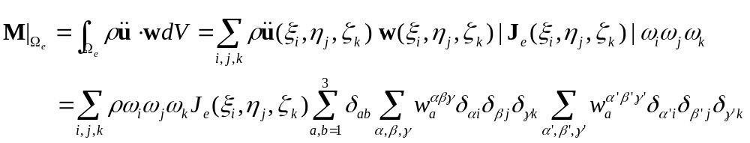 (4)
where J_{e}, the Jacobian of 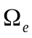, allows to go between the reference and the present element. Correspondingly, Eq. (1) can be reformulated in a compact form
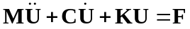 (5)
where C, K, and F are the global absorbing boundary matrix, the global stiffness matrix, and the source term with the specific expressions given in Komatitsch & Vilotte (1998). Eq. (5) can be explicitly marched using a two-parameter Newmark-type scheme
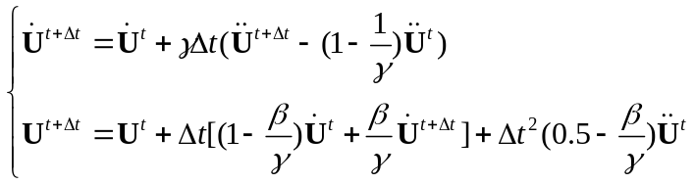 (6)
With Eq. (7)
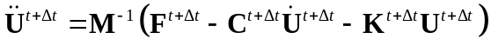 (7)

Kinematic source characterization and implementation in specfem3d

In this section, a kinematic hybrid earthquake source model is presented. The final slip distribution is first characterized by defining slip profiles composed by asperity patches (as a source for the low frequency radiation). This first part is hereafter called as “deterministic slip”. Then, the deterministic slip is perturbed stochastically to introduce heterogeneous small-scale variability to the slip distribution (as a source for the high frequency radiation). The latter is done under the Grave-Pitarca (GP) rupture generator framework (Graves and Pitarka, 2010, 2015).

Spatial variation of final slip

The finite-fault source model can appropriately express the heterogeneity of final slip distribution by dividing the entire fault plane into a multitude of sub-sources. Source parameters of the deterministic slip that describes the spatial variation of slip are generally grouped into two parts: 1) global parameters that characterize the macro features of the rupture plane and 2) local parameters that describe the heterogeneous slip distribution on the rupture plane. The global parameters such as fault geometry and size, total seismic moment and mean slip are set by the empirical formulas proposed by Jiang et al., (2017a, 2017b). The local parameters that characterize the asperity position, size and slip amplitude, as well as the relationship with the global parameters, are set by the empirical formulas proposed by Somerville et al., (1999) and Jiang et al., (2017a, 2017b). The empirical formulas proposed by Jiang et al. (2017a, b) are results of statistical analysis based on the NGA-West2 and eQuake-RC database. If a kinematic source slip model is available, such as one derived from source inversion, this model is assumed to be the deterministic slip

Based on the deterministic slip, a further heterogeneous slip distribution on the fault plane is developed by incorporating in the wavenumber domain small scale variation randomly distributed. It is formulated as:
(1)
where, D_{slip}(k_{s}, k_{d}) denotes deterministic slip distribution in the wavenumber domain (k_{s} is the wavenumber along strike, while k_{d} means down dip one). The maximum wavenumber (expressed as k_{max} = 0.5/d_{sub}) is related to the discrete size of the sub-fault d_{sub}. A(k_{s}, k_{d}) denotes wavenumber attenuation spectral based on the von Karman function, combined with random variable φ∈[-π, π]:
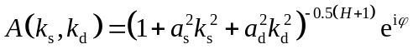 (2)
where, H is the Hurst exponent, which is set to 0.75 according to the Graves and Pitarka (2010), a_{s} and a_{d} are two empirical coefficients related to the magnitude M_{w}:
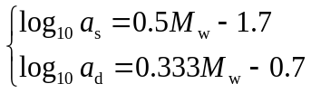 (3)
F (in Eq. (1)) represents the wavenumber combination function, which is used to select the low wavenumber component of the deterministic part and the high wavenumber component of the random part, and it can be expressed as:
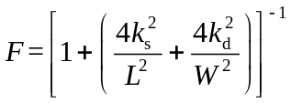
(4)
Where, L and W are the fault length and width, respectively.

Temporal evolution of slip
The source time function, rise time, and rupture speed are the main factors that describe the temporal evolution of slip on the entire rupture plane. These parameters are defined as follow:
Assuming that the shallow layer of the crust is weaker than the deep seismogenic zone due to the formation of incompetent fault gouge, cracking and other forms of brittle rock damage (e.g., Marone, 1998; Marone and Scholz, 1988; Scholz, 2002), the average rupture speed is assumed to be depth dependent following Pitarka et al. (2015). If β₀ is the local S wave velocity, the average rupture speed is set to 56%β₀ in the weak-shallow zone (< 5 km depth), 80%β₀ at depths greater than 8 km, and linearly interpolated from 56-80% β₀ in the 5-8 km depth range.
The rupture initiation T_{ij} is defined as in Graves and Pitarka (2015). These authors introduce random perturbation to the rupture propagation speed as follow:
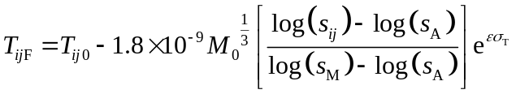 (5)
where, T_{ij0} is the nominal rupture initiation at the ij-th sub-fault calculated from the defined average rupture speed, M₀ is the seismic moment, s_{ij} represents the slip (the minimum threshold is 0.05s_{A}), s_{A} represents the average slip on the fault plane, s_{M} represents the maximum slip among all sub-faults, ε represents the random number obeying the standard normal distribution, σ_{T} = 0.2 is the log-normal standard deviation for the arrival time of rupture front.
The source time function (seismic moment rate) is assumed to follow the function proposed by Hartzell et al. (2007) with a f⁻² high spectral decay characteristic, as follow:
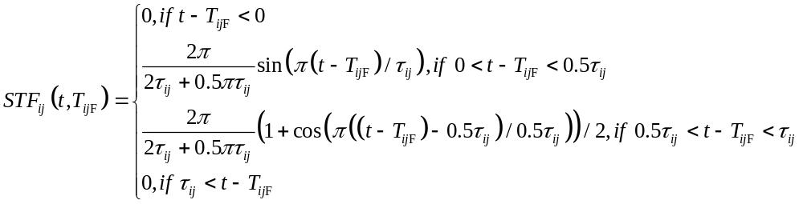 (6)
where, τ_{ij} is the rise time at the ij-th sub-fault.
The rise time at the weak-shallow crust (z < 5 km) is assumed to be twice the one from the deep seismogenic zone (z > 8 km) (Kagawa et al., 2004), with a linear transition between 5km to 8km. Then the rise time with random perturbation can be expressed as:
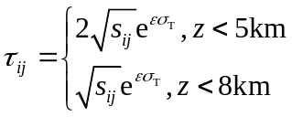 (7)
where, σ_{T} = 0.5 is the log-normal standard deviation for the rise time. Finally, the mean of the rise time on the entire fault plane is adjusted to τ_{A} = 1.6×10⁻⁹M1/3 0.
Finally, the slip direction (rake) is allowed to vary across the fault with a standard deviation of 15° about a prescribed mean value. The spatial distribution of the random rake variations follows a von Karman correlation function, as follow.
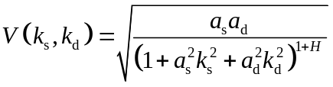 (8)
The whole process to define a hybrid kinematic final slip source model implemented in SPECFEM3D can be summarized into the following six steps (Figure 3): (1) Estimation of the size of the fault and the average slip with the global parameter scaling laws (Jiang et al., 2017a, 2017b). (2) Using scaling law between the global and local parameters, the size and average slip of the main asperity, as well as the position on the rupture surface, are estimated. Then, the final slip outside the asperity is estimated from the average slip of the whole rupture. Up to this step, the deterministic slip has been defined. Notice that if a kinematic source slip model is available, such as one derived from source inversion, step 1 and 2 are skipped and the given kinematic source model is assumed as the deterministic slip. (3) Introduce random perturbation to the deterministic slip in the 2D wavenumber domain so that the slip distribution follows the k-squared spectrum, then transform the wavenumber spectrum back into the spatial domain (Equations 1-4). (4). Calculate the moment tensor at each grid-point and generate the source parameter file CMTSOLUTION for input in the SPECFEM3D. (5) Based on the assumed rupture speed, the rupture initiation (Eq. 5) is calculated and rise time (Eq. 7), both with random perturbations to generate small scale heterogeneities. (6) Finally, the source time function (STF) (Eq. 6) is defined for each sub-source discretized in time assuming a time step for the numerical calculation.

